

Department of Computer Science

Parallel and Distributed Computing Lab -COSC410
Fall 2024
Lab 4: MapReduce Framework in Python
Aim: To familiarize students with hands-on exploration of “MapReduce” framework in Python for Big Data analytics.

Objectives: On completion of this lab, students should be able to understand the following concepts:
- Big Data analytics
- MapReduce programming framework
- MapReduce programming in Python using MRjob library

Risk Assessment: Low

PART I: Introduction to Big Data Analysis

The rate at which data is generated is rapidly outpacing our ability to analyze it. The increase of data opens huge learning and analysis opportunities. However, it also comes with its unique set of challenges such as storage of this data and processing it economically in an acceptable amount of time. The popular term used to describe such datasets is Big Data. Big Data is defined by three versions of data: volume, variety, and velocity.
- volume refers to the size of the data,
- variety refers to the data coming from a variety of different sources and in many different formats,
- velocity relates to the speed at which data is being generated.

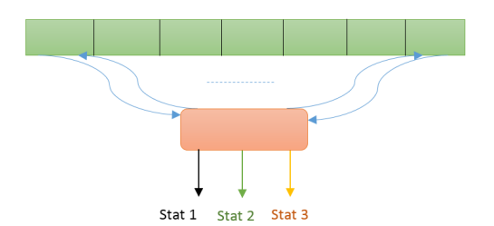
Scalability is defined as the ability to process data when it is larger than the available capacity of the processor. One way to achieve this is to process dataset piece by piece, i.e., to take the first piece of data, operate on it, write the results back then take the next piece of data, operate on it, write the results back and so on.
As an example, when there is an extensive weather dataset consisting of millions of temperatures, humidity, and air pressure readings that cannot fit inside a single processor, it can be analyzed by first breaking it down into smaller blocks and then working on it one block at a time. After processing the last block, the average temperature, average humidity, and average air pressure statistics can be calculated over the entire dataset. This approach which is serial in nature is shown in figure 1.
Figure 1: Distributed processing without parallelism

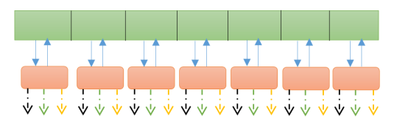
The alternate approach is to parallelize the solution. With this approach multiple processors could be used where each processor works on an individual block of data, while all of them operate in parallel. This approach is called” Scaling out” (or horizontal scaling), and it takes place through an increase in the number of resources available to solve a problem (e.g., adding more hard drives to a storage system or adding more processors to support an application, etc.) i.e. using a cluster. Scaling out is an excellent way to build Big Data applications, as it allows distribution of workloads to multiple processors operating in parallel as shown in figure 2.
Figure 2: Distributed processing with parallelism

Scaling out and parallelizing the solution is an attractive option. However, because of processing different data blocks on different processors, consolidating results calculated over the entire dataset is possible by using distributed algorithms. MapReduce is one category of distributed algorithms.

- MAP-REDUCE FRAMEWORK

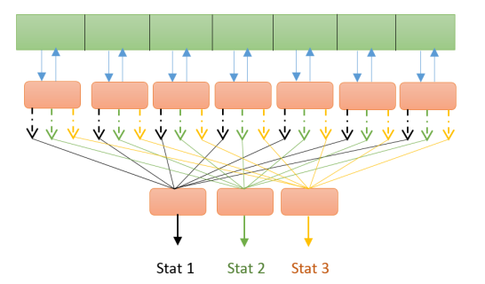
MapReduce is a big data analysis model that processes data sets using distributed algorithms on computer clusters. It started when Google, in 2003, developed and published Google File System (GFS), a scalable and distributed data storage solution to store the large corpus of web crawling data and presented the MapReduce framework to help search and find insights from data stored in the GFS. Inspired by Google’s proprietary GFS and MapReduce, their open-source equivalents were developed by the Apache Software Foundation and became the Hadoop project. Much like Google’s MapReduce is layered on top of GFS, in Hadoop, MapReduce framework is layered on top of Hadoop Distributed File System (HDFS), a distributed fault tolerant storage facility. Hadoop and its variants are currently in use at Yahoo!, Facebook, Amazon and Google-IBM NSF clusters, to name a few.
Figure 3:Multistage Distributed processing with Parallelism

A Hadoop cluster is a collection of computers, known as nodes, that are networked together to perform these kinds of parallel computations on big data sets. Unlike other computer clusters, Hadoop clusters are designed specifically to store and analyze mass amounts of structured and unstructured data in a distributed computing environment. Hadoop clusters consist of a network of connected master and slave nodes that utilize high availability, low-cost commodity hardware. The ability to linearly scale and quickly add or subtract nodes as volume demands makes them well-suited to big data analytics jobs with data sets highly variable in size.

In summary, MapReduce is a programming model and framework designed for processing large datasets in a distributed computing environment. It does not directly use memory as the primary storage mechanism. Instead, MapReduce relies on the distributed file system, typically HDFS (Hadoop Distributed File System), to store input data and intermediate results during computation.

MapReduce consists of two separate and distinct computation phases, the Map phase and the Reduce phase. During the first phase, the framework runs a map function (also called a mapper) in parallel on the entire dataset stored in the HDFS. In the second phase, the framework runs a reduce function (also known as a reducer) on all the data produced by the mappers during the Map phase. The output from the reducers, which is the result of the data processing job, is written back to the HDFS cluster. As the sequence of the name MapReduce implies, the reduce task is always performed after the map task is finished. A map function is executed in parallel on each node in the HDFS cluster that is storing a block of the input data. The mapper reads the block of data one record or one line at a time, depending on the type of data. The data is read record by record if it is structured in nature such as originating from a database, or it may be read line by line, if the data is unstructured such as log files, social media streams. The mapper then processes this record or line of data and outputs the results of its processing in a specialized format. The format is essentially a list consisting of key-value pairs, i.e., {(key1, value1), (key2, value2) ..., (keyn, valuen)}

- A map function takes a chunk of the job’s input and executes some user-defined logic to output a list of key-value pairs. map() is a user-defined function that maps each data record in the data collection.
- A reduce function takes a group of key-value pairs that share the same key and executes some user-defined logic to output a single value for that key. reduce() groups the output of map() with another user-defined function.

To summarize the MapReduce works on (key, value) pairs by performing the below steps:
- INPUT: list of key-value pairs (k1, v1)
- MAP: (k1, v1) >> [list of (k2, v2)]
- SHUFFLE: combine (k2, v2) >> (k2, [list of v2])
- REDUCE: (k2, [list of v2]) >> (k3, v3)
- OUTPUT: list of (k3, v3)

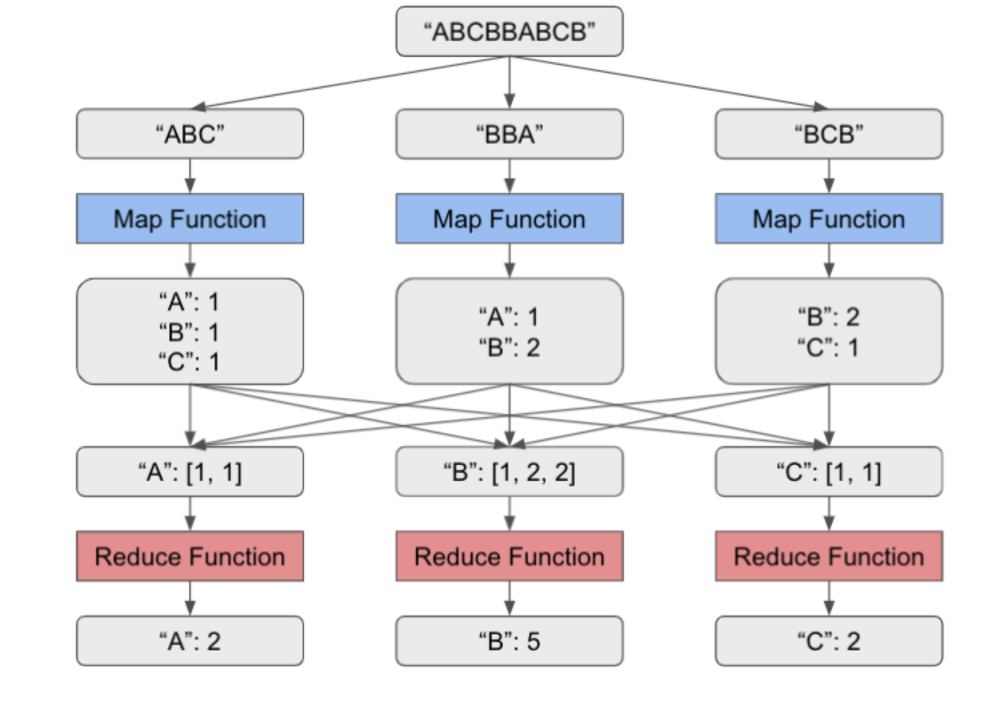
Example: In this MapReduce example of figure 4, the map function calculates the number of occurrences of each letter in the input string, and the reduce function calculates the total number of occurrences of a particular letter. Each gray box indicates the input or output data of the map and reduce tasks. Splitting of the initial input and the shuffling and sorting of the output of the map function into the input of the reduce function are done automatically by the MapReduce framework.
Figure 4: MapReduce Function

- MRjob in PYTHON

MRjob is a famous python library for MapReduce that helps developers to write MapReduce code using Python Programming language. Developers can test the MapReduce Python code written with MRjob locally on their system or on the cloud using Amazon EMR (Elastic MapReduce-Amazon EMR is a cloud-based web service provided by Amazon Web Services for Big Data purposes). This library allows MapReduce applications to be written in a single class using python programming, instead of writing separate programs for the mapper and reducer. It is simple and more pythonic. Some of the features of MRjob library are:
- All MapReduce code is in a single class
- Easily upload and install code and data dependencies at runtime
- Switch input/output formats with a single line code
- Automatically download and parse error logs for Python tracebacks
- Put command line filters before or after the Python code

Ex: To write a program in MRjob for word-count in a text file, first import the MRjob library. Create a class and define two functions for mapper and reducer. Mapper collects the data from a text file and splits it into words. Reducer function counts the frequency of each word and gives us the result in key values.
In Python, class is defined with an indented block like a function definition, except with class instead of def. Instead of a list of arguments, the item in parentheses (MRjob) is a base class that the newly defined class will inherit most of its features from. There are two methods, mapper and reducer, within the class. A class method is like a function (since it is also defined with a def statement), but the first argument to a class method will always be self, a reference back to the object to which the method belongs. The always-present self-argument allows the method to access other members of the same object (both data and methods). However, when a class method is called, there is no need to supply anything for the self-argument as it is implicit.
- GENERATORS in PYTHON

Generators are necessary to understand the yield statements in the mapper and reducer methods. The main issue, in the case of industrial-strength MapReduce, is that there is not enough memory to store all data at once. This is true even after the data is split between many computer nodes. So instead of getting an enormous list of data, the mapper and reducer functions both receive and emit generators.
When a function is run, it compiles until it hits a return statement, at which point it returns some results. Similarly, a generator does its specified calculations until it hits a yield statement. It passes along whatever values it was supposed to yield and then it pauses and waits for someone to tell it to continue. It continues until it reaches another yield, and so on.
Not only are mapper and reducer generators, their (key, value) inputs are also generators. This means that for each step of the mapper, it pulls in one (key, value) pair, does some processing, and then emits one or more key value pairs, which move along to a combiner. This is how MapReduce avoids having to load huge datasets into limited memory.

PART II: Lab Tasks

- Install “MRjob” library on the Anaconda prompt using:
conda install -c conda-forge mrjob

- Save filename.py and datafile.txt in the same folder.

- Run all MapReduce programs from the file location on the Spyder IDE by typing in the external terminal:
python filename.py datafile.txt

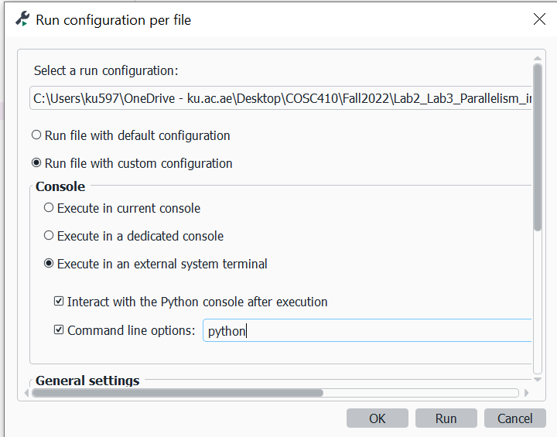

Figure 5: Run configuartion settings on Spyder IDE

Task 1:
(This is a recap of basic Python used to develop the MRjob library)

- Complete the code to get output as [2, 4, 6, 8, 10]:

numbers = [1, 2, 3, 4, 5]
duplicate = list (____ (lambda ___: 2*x, numbers))
print(duplicate)

Fill in the blanks: The function _ applies the ___function to every item of the list. It generates an iterable object that is converted to a list using the function ____.

- Complete the code to get output as 120:

from functools import ____
numbers = [1, 2, 3, 4, 5]
product = _____ (______ x, y: x * y, numbers)
print(product)

Fill in the blanks: The function ____ applies the ______ function cumulatively to the list items. The result of
the cumulative operation is the ______ of all numbers in the list.

- What is the output of the code: __________________________________________

import re
def tokenize(input_string):
words = re.findall(r'\w+', input_string.lower())
return words

input_string = "This is a sample string and contains 11 words."
words = tokenize(input_string)
print(words)
print(len(words))

Fill in the blanks: The first line imports the re module, which stands for ___________which is a powerful
tool for text manipulation and ________. _______ function converts input_string to lowercase to ensure
that the tokenization treats uppercase and lowercase characters as the same. _____ returns a list of all
words in the input text.

- What is the output of the code: _____________

def my_generator(n):
value = 0
while value < n:
yield value
value += 1

for value in my_generator(5):
print(value)

Fill in the blanks: We define a ______ function called my_generator that takes one argument, n. In each iteration, we use the ____keyword to yield the current value. This pauses the generator function and returns the current value to the caller of the generator. The generator function continues to yield values one by one until value becomes equal to n. The generator function yields values lazily, only when requested, making it ________ for generating large sequences.

- What is the output of the code? _________________________________________________

from collections import Counter
input_string = "This is a sample string and contains sample words."
word_list = re.findall(r'\b[a-zA-Z]+\b', input_string.lower())
word_frequencies = Counter(word_list)
print(word_frequencies)

What is the keyword “Counter” used for?

Task 2:
Write an MRjob program that takes text as input and counts how many lines, characters and words are in the text. Use task2.txt file as input (uploaded on BB).
Include text of the program code and screenshot of results

Task 3:
The data input file task3.txt is uploaded on BB. This contains a list of six-letter words, all consisting of lower-case letters only. Use MRjob library to write a program that finds all anagrams in the text document.
Include screenshots of the program and results

Task 4:
The data input file movie_ratings.txt is uploaded on BB. This contains the user-id, movie_id and movie ratings. Write a MapReduce program to output most rated the movie_id.

Task 5:
The data input file movie_names.txt is uploaded on BB. This contains movie_id and movie names. Modify the code of task4 to output the movie name with highest rating.

